**Building Job Recruitement With Machine Learing | HR Performance Python | Job Placement Python**

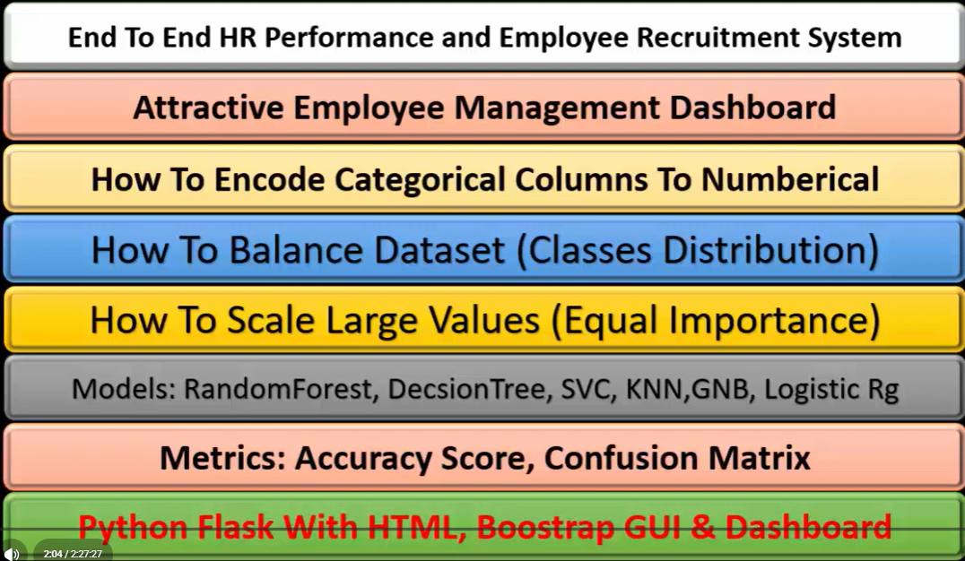

**📊 Dataset Overview**

* **Rows:** 215
* **Columns:** 15

**🧩 Column Details**

| **Column** | **Description** |
| --- | --- |
| sl_no | Serial number (identifier) |
| gender | Student gender (M/F) |
| ssc_p | Secondary school percentage (10th grade) |
| ssc_b | Board of education for SSC (Central/Others) |
| hsc_p | Higher secondary percentage (12th grade) |
| hsc_b | Board of education for HSC (Central/Others) |
| hsc_s | Stream in higher secondary (Commerce/Science/Arts) |
| degree_p | Degree percentage |
| degree_t | Type of degree (Sci&Tech, Comm&Mgmt, Others) |
| workex | Work experience before MBA (Yes/No) |
| etest_p | Employability test percentage |
| specialisation | MBA specialisation (e.g., Mkt&Fin, Mkt&HR) |
| mba_p | MBA percentage |
| status | Placement status (Placed / Not Placed) |
| salary | Annual salary offered (only for placed students) |

**🧠 Idea Summary**

This dataset is about **MBA student placement data**, showing their academic background, work experience, test scores, and whether they were placed or not — along with salary details for placed students.

**💡 Project Ideas**

Here are a few directions you can take:

1. **Placement Prediction Model** — Use features like degree_p, workex, etest_p, and mba_p to predict whether a student will be *Placed* or *Not Placed*.
2. **Salary Prediction** — Predict salary based on academic performance and specialisation.
3. **EDA (Exploratory Data Analysis)** — Analyze which factors influence placement chances (gender, work experience, degree type, etc.).
4. **Dashboard / Visualization Project** — Build an interactive dashboard (e.g., in Power BI, Tableau, or Plotly) showing placement rates, salary distribution, and performance trends.
5. **Statistical Study** — Correlation between MBA marks, employability scores, and salary outcomes.